PO Annex template

ITEA 3 Call 5

Foreword

Do not remove or modify in any way the sections having these notations,

All guidelines in the template appear in this “boxed” format. These instructions, as well as the preceding title page (“PO Annex template”) and this foreword, should never be removed manually from the submitted files: they are automatically removed by the merging function of the ITEA Community website. Potential layout issues appearing when removing the instructions (e.g. a large image leaving half a page blank) will be adjusted by the ITEA Office, between the proposal submission and the transfer of the generated PO/FPP to the reviewers.

NB: all texts between “<” and “>” symbols (incl. on the front page and in the headers) should be replaced or removed.

It is highly recommended that you carefully read all the instructions provided: they indicate for each chapter and subchapter what is expected and must be carefully taken into account.

It is crucial that proposal writers comply with the pre-defined formatting and styling rules: breaking these rules may create errors when inserting the auto-generated sections and thus cause the merge process to fail. Complying with formatting rules can be achieved by adhering to the following guidelines:

* do not remove any predefined title and do not add headers, incl. annexes, that are not supposed to be defined according to this template, at any level of the hierarchy (e.g. do not add a §5 after §4 Rationale for public funding); in particular, for references or publications, as additional annexes are forbidden, please rely on footnotes; you are, however, free to add subsections when there is no subsection yet defined (e.g. you can define a subsection §2.2.1.1 within §2.2.1 Market analysis);
* do not modify the predefined styles, except for standard “emphasis” effects (i.e. underlined or bold text) – we recommend using the underlined and bold formatting in a consistent and prudent way throughout the document, and on body text exclusively;
* only use the pre-defined styles that start with “ITEA_”: the most relevant ones are “ITEA_BodyText” for standard paragraphs (Arial 10 with a line spacing factor of 1.2 pt), “ITEA_BodyBullets” for bullet points within standard paragraphs and “ITEA_Figure”; for captions, you can use the standard “Insert Caption” function from Word, as it will automatically use the “ITEA_Caption” styling; these styles are accessible in the “Quick Styles Gallery” of the “Home” tab;
* do not remove the instructions (both green and orange ones), and do not remove the auto-generated sections, incl. the annexes;
* do not overload the document with uncompressed / excessively large images; a proposal should ideally fit in less than 10 MB.

It is in the interest of consortia to ensure that a merged document (i.e. including auto-generated sections) can be generated and downloaded before the submission deadline so that all the relevant information is provided in the project proposal document.

Items that need to be filled in exclusively via the ITEA Community website will have the following notation:

Auto-generated section: input to be provided only on the Community website.

Do not remove or modify in any way the sections having these notations throughout the whole Annex template since they are needed to automatically merge the information provided via the ITEA Community website with your uploaded Annex document.

Important guidelines for a successful PO-FPP preparation

1) The length and quality of the proposal

The quality of the writing and the total length of a proposal has an impact on the evaluation by the Public Authorities and the ITEA Steering Group.

Please avoid being verbose and keep the PO or FPP concise and informative. Use bullet points or a table to provide lengthy information in an efficient format. Succinct writing without unnecessary words and sentences will ensure better evaluation.

Section length recommendations (in number of words and pages) have been made to suggest the ideal length of the PO and FPP for the evaluation. The overall length of the final merged document, excluding section §4 and Annexes, must not exceed 45 pages for a merged PO and 75 pages for a merged FPP, which corresponds roughly to an uploaded file of 55 pages for a PO, and of 85 pages for an FPP (all sections included, i.e. including comments and empty auto-generated sections). A merged PO or FPP that exceeds the recommended length up to section §4 can have a negative impact on the evaluation.

2) The usage of Google Docs

The PO-FPP template cannot be copied to Google Docs and re-copied to the original PO-FPP template properly due to compatibility issues. When using Google Docs, please only copy the final “body text per paragraph” from the Google Doc and paste it to the original PO-FPP template. Do not copy the paragraph headers or other styles from Google Docs, which could corrupt the styles used in the original PO-FPP template.

3) Value chain analysis and design

ITEA provides extra guidelines for Chapter 2.2.1. ‘Market analysis and market value chain’. It is highly recommended to take the proposed tools in the guidelines into account for the PO-FPP. A high-quality market analysis and market value chain description will ensure positive PO-FPP evaluation results. These guidelines can be found at the end of the PO template in Annex B.

Project Outline Annex

<ACRONYM> or <PROJECT NAME>

<FULL PROJECT NAME>

Edited by: <name>

Date: <date>

Apart from the State-of-the-Art-dedicated text (§2.3.1) which is handled by the ITEA Office as public information, unless otherwise specified by the consortium, this document will be treated as strictly confidential.

Project key data

Auto-generated section: input to be provided only on the Community website. Do not edit or remove this box and do not provide any text within this annex in this chapter, but provide the requested information directly on the ITEA Community website.

The inserted key data will contain (among others) the acronym, full title, time frame, the respective countries and partners per country, the coordinator, as well as a short description which should include the project idea, the main expected market impact and the main technological objective.

Table of Contents

Project key data 5

Project acronyms 7

1. Project one-page description 8

2. Project overview 9

2.1. Rationale of the project 2

2.1.1. Problem statement, solution and challenges 2

2.1.2. Project innovations and technology value chain 2

2.2. Targeted impact 10

2.2.1. Market analysis and market value chain 2

2.2.2. Consortium market access 2

2.3. Technology 12

2.3.1. State-of-the-Art (SotA) analysis 2

2.3.2. Proposed technological innovation and novelty in relation to the SotA 2

2.3.3. Expected project outputs 2

2.3.4. Quantified objectives and quantification criteria 2

2.4. Consortium overview 15

2.4.1. Cooperation added value: business level 2

2.4.2. Cooperation added value: technology level 2

3. Work description 17

3.1. Project structure 2

3.2. Main milestones 2

4. Rationale for public funding 19

Annex A: Summary of costs & effort breakdown 21

Annex B: Guideline for the value chain analysis and design 22

Project acronyms

|  |  |
| --- | --- |
|  |  |
|  |  |
|  |  |
|  |  |
|  |  |
|  |  |
|  |  |
|  |  |
|  |  |
|  |  |
|  |  |
|  |  |
|  |  |
|  |  |
|  |  |
|  |  |

1. Project one-page description

(Maximum length: not more than one page, approximately 600 words)

Provide, within one page maximum, a strategic description of your proposed project addressing:

* the context and goals of the proposal;
* the business relevance and the targeted market impact;
* the innovative aspects and the major expected technical outcomes;
* the consortium relevance.

Distributed Ledger Technologies are not only one of the main technological advancement in the last decade, but also it is probably the most famous technological innovation which is scattered to all public due to a new and volatile investment tool which is born by DLT: Cryptocurrencies. Although, those crypto-coins are only the viewable peak of the iceberg and this new technology promises huge amount of innovations besides being an investment tool. In I-Delta Project, we would like to focus on having a fully compliant DLT based platform brings interoperability, integrability to existing automations/systems and another hype of this era: IoT. In order to achieve those ambitions, we entities from seven different countries, will be cooperating with our pilots from different domains.

One of the era in I-DELTA project will be focused on smart cities and smart energy carried out by Spanish consortium. Regardless of smart electricity , this system will help organize and schedule user electricity consumption cycles proposing most available and suitable offerings to minimize their costs. Integrating blockchain technologies with IOT platforms will help extract the relevant information such as hourly electricity usage amounts belonging to each customer, to predict how much energy will be consumed during next hours which helps to calculate cost of electricity consumption. Secondly, this development will offer smart scheduling system that will calculate the optimal time-slots and their frequencies to pick up the wastes around the cities. The working principle lies in assigning a unique ID to each customer served as digital wallet to pay different services by buying smart cities tokens defined in the project.

IDELTA will target reliable, secure, interoperable and consistent document management and governance in ERP system carried out by Canadian and German partners in aerospace and supply chain industries respectively .The main objective here is the acceleration and optimization of document management and tracking systems sourced by ERP systems in different companies. To prevent heavy load of email trafficking and document sharing and to eliminate the some steps related auditing and tracking document, digitalization of requirements and constructing shared database participation by diverse stakeholder-set will be required. Using distributed technology platform instead of centralized system will reduce the burden of time in exchange of files and documents. Employing DLT technologies provisions secure but efficient services to wipe out potential errors and compliances. Users can trace the latest version of document and they can verify the reliability as well as authenticity of document. They can also check and quality control steps resulting in fraud detection and illegal procedures. It will also leverage document accessibility by the people in the environment.

I-Delta aims to examine interoperability of these different DLT’s, with integration of smart environment, city, community and production solutions allowing global-scale systems which use, for instance, a Blockchain implementation, to communicate with another system that is using an implementation of Tangle or Ethereum. Interoperability standards as well as the underlying cryptographic infrastructure have to be deeply analysed; requirements of different domains should be refined and homogenized; a common reference architecture which serves to the same technological problem with the perspective of different domains, need to be defined in order to achieve this goal. Preserving privacy according to new GDPR and obeying the both global and national legislations during providing solutions is another key aspect of the project.

1. Project overview
   1. Rationale of the project
      1. Problem statement, solution and challenges

(Maximum length: 1200 words)

Describe the problem that the project aims to solve. Explain the current issues, limitations or bottlenecks of what currently exists, explain the needs you plan to satisfy or to create.

Describe the high-level solution that the project intends to explore and implement to solve the problem. Give reasons why this solution will solve the problem. Also indicate how well the solution will solve the problem by defining SMART (Specific, Measurable, Achievable, Relevant, Timely) objectives for your project.

Describe the societal, economic and/or technological challenges that will be addressed by the proposed project.

This subsection describes the context and background relevant to the project, in terms of technological and market status, not the project itself. It should convince evaluators that the project partners have a good understanding of the context in which they will be evolving, both technology- and business-wise..

Problem 1: Complex scenarios of multiple business relations and necessity of a massive amount of documents and files exchange among heterogeneous platforms result in in erroneous and illegal compliances and frauds.

Proposed Solution for Problem 1:

* The de-centralised DLT data store thus eliminates all “single points of failure”, which could range from HW failures down to unilateral manipulations of data. In addition, Smart Contracts support the integration of tax logics and rules into the DLT. Distributed Ledger Technology (DLT) represents a promising approach to interlink the various actors in the taxation realm (tax authorities, companies and auditors). These also allow for the monitoring of any exchanges between supply chain stakeholders in order to, e.g., automatically check the compliance of incoming documents or to get, in quasi real-time, an overview of current turnover balances

**Challenges:**

• Redundant required transaction confirmations

**Problem 2: Smart home technologies are currently subjected to risks such as access to the private network , message corruption, record modification, information disclosures that lowers reliability of system**

**Proposed Solution for Problem 2:**

Greater control over own data, and how it can be used mitigates the potential risks sourced by smart home appliances usage. DLT has unique properties when it comes to inherent trust, immutable record keeping, shared computing power, and self-governing network. It provides all IoT-manufacturers a base network to run their own IoT network on, verify identities, and safely transact information. The missing glue that binds separated IoT networks with a communication bridge can be solved using DLT.

**Challenge:**

• Transaction throughput

• While the transparency of DLT may be seen as a positive, many forms of device/gateway communication require absolute privacy

• No one-purpose chain for distributed file storage, Smart Contract execution, and on-chain identity + transaction validation

• Permissioned or permission-less cross-chain communication

• Great costs for on-chain finality and computing power for Smart Contract

• Multi-signature payment channels are not live on suitable Smart Contract Platforms

**Problem 3: Hidden ethical claims and procedures lessen the services reputation and trustworthiness . Customer prefers more transparent systems to verify their certification.**

**Proposed Solution for Problem 3:**

Transparency comes with blockchain-based time stamping of a date and location for various domains such as loyalty systems and smart energy applications. An digital wallet application will be developed to assign each transaction and participant an ID that can be propagated over the all the blockchain. . Every company in the network can easily reach the DLT for verification by only joining the network.This system will enable users to trace down all the steps from to the beginning to the end of the cycle. It will display all the related details to the customer on demand.

**Challenge:**

* Integration of diverse and huge amount of data in the blockchain might lead to problems.
* Integration of the digital wallet and tokens with current financial systems

**Use case presented by Turkish consortium:**

**Proposed solution:**

A Digital Employee Identity is the solution for the problem. In this scenario, companies don’t need to know the personal information, they just need a verification. A DLT which holds hash codes of the employee ID cards, could easily provide the verification of digital identities. DLT also reduces, many bi-directional integrations with any two companies

**Challenge:**

One of the biggest challenges would be granting each citizen with a unique online identification which would serve the purpose of associating a wallet to the citizen as well as possibly identifying it for different smart city services which are eligible to it.

**Problem 4: Exposure to cyber attacks such as tampering ,spoofing,** **privilege escalation attack, eavesdropping leads to blackouts, energy theft , customer privacy breach and safety of operating personnel**

**Proposed Solution for Problem 4 :**

Block Chain offers encryption and validation. Everything that occurs on the Block Chain is encrypted and it’s possible to prove that data has not been altered. Additionally, the private Block Chain can restrict access to specific users. Anyone accessing the private Block Chain will have to authenticate their identity to gain access privileges and can be restricted to specific transactions

In what way? What type of application will be developed? How will it work?

**Challenge:**

In order to support the smart grid management and data sharing for smart contract, enhancing the interoperability of distributed ledger technology become an important issue. The interoperability of distributed ledger refers to the ability to set up common understanding to against the heterogeneity of the blockchain technologies which relies on the best future as well as limitation.

**Problem 5: Such systems offers constrained range of services to meet customer expectation.** .

**Proposed solution for Problem5:**

By integrating a private blockchain with the various control and monitoring applications, we can create a new level of engagement with consumers. The system increases trust and enables consumers to become prosumers and active participants in the relevant market. The customers can choose from which services they want to be benefit. In Smart energy domain. Customer preferences are noted in a Smart Contract and thereafter executed on automatically to guarantee supply with electrical energy from the preferred energy generation plant. The delivery is verified by transferring the coded kilowatt hour to the customer's energy wallet. Thus, blockchain technology enables the buying and selling of the renewable energy generated in the neighbourhood micro grids.

**Problem 6: The excessive amount of processes such as transfer, exchanges, solation and filtering incurring periodically degrades the system performance and scalability.**

**Proposed Solution for Problem6:**

**A platform will developed to enable user** to put their documentation on the blockchain as well as enable regulatory compliance sign-offs by authorized signatories.This platform offers document management and audit services in context of  offer participation in its blockchain solution to all stakeholders in the aerospace supply chain from component part manufacturers, to assembly, wholesalers and end-customers. Mavennet’s solution enables component, sub-assembly, assembly and aircraft manufacturers With the immutability of the Mavennet Platform, users can ensure that time-stamped documentation is available in near real-time along with assurance that the documentation is the latest version for that part as well as approved by a qualified and identifiable individual. With Mavennet’s platform, users will be able to track a part as it is used down-stream from the manufacturer. They will be able to see if a part has been moved from one vehicle to another or even discarded. Furthermore, they will be able to trace where similar parts are being used. This is extremely helpful in the event of a part failure so that a company can minimize risks as soon as they are identified.

The Benefits proposed by Mavennet Platform are mentioned below:

* Greatly reduced efforts to retrieve relevant documentation for each part reducing the process from months to seconds
* Enable compliance with regulations so that efficiencies can be gained both at source as well as downstream

Increased access to documentation so that all partners in the ecosystem can see relevant documentation without help from external stakeholders

**Proposed by Canadian Consortium:**

In industries that demand high-quality parts, they also demand detailed and accurate documentation with the associated quality sign-off processes. The Airline industry has strict compliance protocols to standardize quality management. These regulations require that all of the more than 2,000,000 parts per aircraft, have the exact documentation including proof of sign-off by qualified staff members no matter where in the supply chain the part was manufactured, stored or maintained. The aerospace value chain is comprised of thousands of suppliers. Overwhelmingly, each supplier retains their own isolated ERP system. In the event of tragedy, audit or other component tracking requirements, the process of isolating said part can take months in some instances. Aerospace supply chains are extremely fragmented, with thousands of stakeholders, transacting billions of parts.

**Proposed Solution:**

Seizing the opportunity to re-invent and lead the industry’s documentation process, Mavennet has designed a solution that builds up from base-level components to completed aircraft.

**Challenges:**

* Digitization of requisite documentation •
* Shared database participation by diverse stakeholder-set

**Problem 7: The constrained accessibility of platforms impacts on system effectiveness**

**And utilization.**

**Proposed solution for Problem 7:**

Current loyalty applications are not flexible due to lack of number of beneficiaries (citizens, employees) and strong centralization; integrating several entities into one environment will lead to frauds and free riders. Our plan to incentivize more people to join our program is loyal application development relies on distributed network mechanism instead of centralized system. Loyalty programs integrated with blockchain technology brings out two major benefits , unlimited liquidity related to free trade mechanism where Coins for Bitcoin and other cryptocurrencies can be exchanged freely approved by many people, and other one buoyancy, suppressing feelings of misgivings and demotivation when consumers find that their $100 worth of points in one program trades for only $70 worth of gifts in another program.

.

**In what way ? What is your plan to build more collaborative platform? How will it work**

* + 1. Project innovations and technology value chain

(Maximum length: 1200 words)

Present here a brief view of the project innovations you are introducing: focus the description on novelty in terms of the state-of-the-art. Innovation can include both technological, process, usage and business model innovations. Explain what the project brings to the table, how it differs from existing results and previous or current projects, products and services, how partners will be able to differentiate themselves from existing market actors and become competitive (or how they can create or reimagine a market). Remain concise in this section (cf. §2.2 and §2.3).

Describe in a few words what the project aims to achieve and how it backs the broader goals of the main partners.

Introduce also the technological value chain(s): it is a kind of modular architecture comprising the main functions and building blocks required to create the solution, as well as their interactions.

This subsection should convince evaluators of the novelty of the project proposal.

* Using blockchain/DLT technology to lower the costs, simplify the management and provide transparent and secure IoT services in the smart communities (Smart Grid, Smart Cities).
* Interoperability of IoT services based on distributed ledger and smart contract shall be maintained
* General blockchain/DLT model and architecture in the hierarchical fog-cloud-based IoT system shall be developed with context-aware and scalable PoW, ledger and smart contract mechanisms
* Blockchain/DLT technology shall be advanced with IoT and clouding-fog based technologies, including consensus protocol performance, privacy and trust keeping mechanisms, cross-chain communication, transaction throughput and validation procedure etc.
* Our project shall foster the development of blockchain/DLT technology by applying it in different IoT application domains with different network infrastructure to handle performance and cross-chain communication related problems.
* Tax-auditing program, ensuring indirect tax compliance and auditability and contributing to the effectiveness of real-time reporting shall be developed. User shall pull up the entire commercial (logistics) chain for an item from a valid invoice and execute additional checks on the (TAX) validity of the business transaction. User pull up the entire commercial (logistics) chain for an item from a valid invoice and execute additional checks on the (TAX) validity of the business transaction, such as:
* Check/confirm supplier fiscal data,
* Check/confirm customer fiscal data,
* Check/confirm VAT determination/category (%, high, low, …),
* Check/confirm and get notified if a business partner is traced to a VAT loss and/or has been involved in “carousel movements” of good
* Similar to the previous point, the pilot must count with a steady base of service providers capable of granting the participating citizens reason to use their tokens in exchange for services.
* A wallet based identity software platform shall be improved to keep the system more transparent and secured.
* A blockchain-based regime will be likely to require every valid “VAT invoice” to have a digital fingerprint (derived through the VAT blockchain consensus process). The fingerprint would immediately identify that the block under scrutiny is permanently linked to the previous and subsequent blocks. The entire history of the commercial chain (forwards and backwards from this transaction) could be followed.

**Technological Value Chain:**

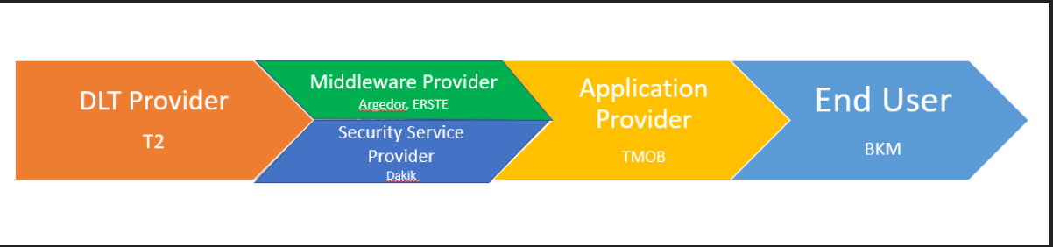

Introducing blockchain/DLT technology into the hierarchical fog/cloud based IoT domain may foster the development of several technologies.

1. **Security/privacy/trust technology:** The current existing security/privacy/trust technologies are generally based on encryption and a third-party authority. This does not suitable to the IoT environment, where the capabilities of IoT devices are constrained. Through our project, the performance of providing security/privacy/trust in the distributed way will be evaluated.
2. **Edge computing technology:** Edge (fog) computing integrates the limited memory, storage and computation resources in networking nodes closer to where data are generated and consumed, and allows to make intelligent decisions in short (real) time satisfying the requirements of users. Our project will push the development of edge computing technology when edge nodes are involved in the distributed ledgers, transaction validations and smart contracts.
3. **DLT Technologies(T2):** Distributed Ledger Technology (DLT) represents a promising approach to interlink the various actors in the taxation realm (tax authorities, companies and auditors). The de-centralised DLT data store thus eliminates all “single points of failure”, which could range from HW failures down to unilateral manipulations of data. In addition, Smart Contracts support the integration of tax logics and rules into the DLT. These also allow for the monitoring of any exchanges between stakeholders in order to, e.g., automatically check the compliance of incoming documents or to get, in quasi real-time, an overview of current turnover balances. In this context of document exchange and storage, the DLT takes on the role of a middleware function with its own business logic. Different to “traditional” middleware DLT represents a de-centrally executed business logic, not run by a single instance. The use of such a middleware thus will allow a standardised document exchange and will correspondingly support the development of future document exchange interfaces according to the given standard of this middleware. This results in efficiency gains, requiring the participating companies to develop and maintain related interfaces only once instead of implementing and maintaining several interfaces, depending on the various business partners. All DLT participants provide also for access to only one, unambiguous and consistent data storage, which can be consulted in case of audits or legal disputes.
4. **Application Provider:** Mavennet has built a private instance of the public Aion network called Aion for Enterprise (AFE). AFE enables high transaction throughput and interoperability between multiple blockchain platforms. This solution gives users the best of all words, including access to both private and public blockchains as well as access to heterogeneous blockchain networks.

**AFE's primary value propositions are:**

• Interoperability with public Aion and other public and private blockchains

• High transaction throughput

• Hybrid modular architecture between AFE and Aion public that can serve any business need

• Global ecosystem of enterprise clients and developers

AFE uses Aion's Multi-Tier Bridging Protocol (MTBP) to enable cross-chain transactions between their enterprise solutions and any other private or public blockchain. This is done by running special nodes in the connecting blockchain to listen for cross-chain transactions. When a cross-chain transaction is made, these nodes generate a smart contract that sends the transaction to the Bridge Cluster of nodes. The Bridge Cluster builds an internal snapshot of AFE and the connecting blockchain and proposes the crosschain transaction simultaneously on each. The transaction is then communicated to Aion Clients, which bundle bridge transactions and submit a Bridge Contract to AFE to finalize the cross-chain transaction. With its pBFT consensus, AFE provides high transaction throughput of over one thousand transactions per block and new blocks added every 2 to 3 seconds. Comparing this to the transaction throughput of the Aion public network of 70 transactions per second, one can see how pBFT makes the Aion interoperability offering more applicable for enterprise clients who demand commercial transaction speeds. Further, Mavennet’s hybrid public-private architecture uses a common suite of products and tools for building enterprise applications and decentralized applications (dApps) on public Aion. This enables AFE and Aion public to be used in conjunction to serve any business need. Throughout this project lifecycle, this enterprise’s feature’s will be enhanced and configured relied on system requirements and wil be integrated with other developed application and frameworks to create smart and collaborated environment.

1. **Middleware Provider:**. Middleware in IIOT platform is the place where all data coming from different resources and heterogeneous network is processed and analyzed via machine learning based algorithms. Once contextualized and validated, data will be transferred to the relevant components and devices. In other words, middleware is in charge of data brokerage among physical and virtual objects. A Device can communicate directly with the IoT Integration Middleware if it supports an appropriate communication technology, such as WiFi, a corresponding transport protocol, such as HTTP or MQTT, and a compatible payload format, such as JSON or XML. Otherwise the Device communicates over a Gateway with the IoT Integration Middleware. The IoT Integration Middleware is not limited to the functionality described above. Choosing the right type of middleware for IIOT platform will help eliminate the reliability, security and interoperability related issues. During the project, the following items will be scrutinized
   * Integration of many different data sources in real time, e.g. blockchain clients, various backends (digital wallet application,tax auditing platform , legacy systems etc), cloud services, partner APIs, and others
   * Gateway and API management
   * Combination of different blockchains
   * Data discovery to find insights and patterns in historical data, sometimes including machine learning
   * Correlation of blockchain and non-blockchain events in real time, sometimes including applying machine learning and analytic models
   * Identity and crypto services to ensure secure and governed communication of all stakeholders in the enterprise architecture



1. **Applying ZKP based Algorithms to ensure the security and safety of platform;**

Using simple symmetric and asymmetric encryption to secure some data between two parties is not a good solution for DLTs. The biggest value of DLTs is trust between parties. By simply encrypting data between two parties make other parties useless for the data and creates a P2P channel. Other parties cannot understand the operations and cannot make an effective role in consensus. As a solution to this problem, cryptographic algorithms can be mixed and matched with sophisticated methods and other algorithms to create proofs that can be voted by all parties while not revealing sensitive information. This method mostly known as zero knowledge proof (ZKP). In I-DELTA project, we are going to offer practical zero knowledge algorithms for the common problems. On top of data layer, I-DELTA will provide a ZKP layer that can be used as an API with user-defined smart contracts. With the help of ZKP, the items mentioned below will be addressed;

* Verification of balances of accounts without knowing their real balance
* Verification the validity of an amount of asset transfer
* Verification of a field of digital identity without revealing personal information (such as verification age restriction without revealing age and other personal information)
* Verification of DNA similarities between two people (such as parent test) without revealing any subset of DNA information
  1. Targeted impact
     1. Market analysis and market value chain

(Maximum length: 2700 words)

Present here an analysis of the markets targeted by the individual project partners. The targeted markets can differ per partner. It is better to describe these specific markets rather than giving some general market report figures. Describe and quantify the current situation and trends in these markets, the main players, main products. Do not rely solely on current market situations but consider also predictions and estimates of future growth from the latest studies.

Describe the existing or announced industrial products or services in the project domain. Explain which competitive advantages the market leaders have and how differentiation could be achieved towards them. Detail why smaller actors are restricted to low market share (e.g. targeting niche markets or competitiveness issue) and how volatile the market currently is (are there more and more actors or is it the opposite? In the latter case, does it derive from market consolidation or from competitors dying out?).

Present existing and potential and/or forecasted competitors (e.g. Google in the car industry). Do not hesitate to introduce Porter’s five forces model of competition to describe (in addition to the current industry competitors) not only suppliers and buyers, but also potential new entrants as well as threat of substitutes.

Describe the current market value chain(s). The market value chain is a representation of the various processes involved in producing products or services and delivering them to the market. It indicates where and how value is considered and created, and how the market actors in their respective markets can be profitable. It also describes the actors’ strategies and relative positioning: it must show all the actors involved in designing, producing, distributing the products and/or services and the relationships among them. All the peripheral actors who can influence the market(s), through regulations, recommendations, indirect suggestions, etc., must also be included. Describe clearly the interfaces between these actors and define the customer – provider relationship(s) wherever relevant.

ITEA provides an extra guideline for the value chain analysis and design. The guideline proposes a set of tools to facilitate the analysis and design of the business strategy of any ITEA projects. It is highly recommended to take the suggested tools into account in this chapter. The guideline can be found at the end of PO template in Annex B.

This subsection should convince evaluators that the project partners have a clear and detailed understanding of the market they are targeting, including not only the current situation but also the current trends, forecasted evolutions and potential threats.

< Text to be inserted here>

* + 1. Consortium market access

(Maximum length: 4500 words)

Describe how the introduced innovation will help the individual partners to achieve competitive advantage in their targeted markets. Clearly indicate and quantify the commercial opportunities that can be achieved with the targeted innovations.

Provide an overview of which targeted project outcomes will be (commercially) exploited in which markets and by which partners.

If applicable, indicate the impact, if any, that the project innovations will have on the current market value chain.

The detailed exploitation plans for each of the partners must be filled in online on the ITEA website and will be included in chapter 4.

Detail also in this section the consortium strategy deployed towards achieving the exploitation goals, for instance (and when relevant) through:

* Standardisation:
* Standardisation includes de jure/de facto standards, published APIs, open source repositories and associated communities, etc. Standardisation should be a way to enable exploitation plans, e.g. by enabling a market to take off, by helping integrators to embrace the proposed technology, by counterbalancing proprietary solutions of leading competitors, etc.
* When relevant, define a standardisation strategy consistent with the project and document its implementation. Projects having software- or system-engineering related activities should, whenever applicable, identify the open source strategy or the tools interoperability strategy.
* When Open Source Software is considered, explain how the project intends to build (on) a large, lively and strong community around the open source software and how the impact from the project will be quantified.
* Dissemination:
* Consider here dissemination towards customers, communities (industrial, scientific, etc.), incl. communications, seminars, workshops, conferences, papers, courses, etc. Dissemination must be a tool to make potential customers or partners aware of the project achievements and results, within and outside the organisations participating in the project.
* Define and justify a dissemination strategy supporting and having impact on the project, i.e. justify the choices made (e.g. why selecting given workshops rather than others). Indicate how the project results will be disseminated in the course and at the end of the project, i.e. by means of (e.g.) which presentations in workshops and conferences, publications, etc.

If fast exploitation is expected, explain what exactly is targeted, and how the consortium intends to achieve these goals.

This subsection should convince evaluators that the consortium is credible, legitimate and relevant to address the market and to exploit the project results (if successful) to generate business (i.e. that it can have an impact on the market). This subsection should be market oriented and should only focus on the long-term goals of the project (i.e. what is expected to be achieved thanks to the project outcomes, i.e. after the project closure).

<Text to be inserted here>

* 1. Technology
     1. State-of-the-Art (SotA) analysis

(Maximum length: 3000 words)

Describe the current technological situation in the project domain with a detailed technical state-of-the-art, with regard to current products, prototypes and research results and trends, both on the industrial and academic sides.

For the research state-of-the-art (SotA), also document how your proposed project relates to, and/or builds on results of, and differentiates from, other (past or running) cooperative (e.g. ITEA, H2020, or national) projects or national ICT clusters tackling related issues: we recommend filling in, for each of such projects or national ICT clusters, a short description thereof in the suggested table below, focusing on the aspects related to the proposed project and a short description of how the proposed project relates to, and/or builds on and differentiates from it. Please note that in this table below, the last column, “Relationship”, should explain:

* which input modules will be reused from the mentioned project;
* and/or what will be transferred from this proposal to the mentioned project;
* or the reasons why the consortium does not intend to reuse/transfer results from/to the mentioned project (i.e. why the results already achieved are not useful for this proposal).

NB1: The ITEA Living Roadmap (accessible through the ITEA Community website) provides a rich source of information with regard to the existing SotA. Use it but go also beyond its content to extend the known SotA (e.g. with the very latest products, achievements, publications, etc.).

NB2: For each past or running ITEA project, a two-page description ("Leaflet") is available on the ITEA public website.

The state-of-the-art described in the project proposal will have to be updated / extended in the course of the project and integrated in a public deliverable. Except for specific cases, the state-of-the-art section of the project proposals will be considered by the ITEA Office as a public document which could be added to the Living Roadmap.

This subsection should convince evaluators that the project partners have detailed knowledge of the technological background (and evolution) in the targeted field. ITEA considers the State-of-the-Art analysis as a key tool to clearly understand and steer innovation all along the project lifespan.

<Text to be inserted here >

Link to previous and/or current collaborative research projects:

|  |  |  |  |  |
| --- | --- | --- | --- | --- |
| Project Name | Cooperative Programme | Time period (approx.) | Technical Focus | Relationship |
| <ACRONYM> | <e.g. ITEA> | <2010-2013> | <Text to be inserted here> | <Text to be inserted here> |
| <ACRONYM> | <e.g. H2020> | <2012-?> | <Text to be inserted here> |  |
| <ACRONYM> |  |  |  |  |

Table 1: Related collaborative research projects.

* + 1. Proposed technological innovation and novelty in relation to the SotA

(Maximum length: 2500 words)

Clearly explain the progress and technological innovation proposed by your project, with reference to the current technology state-of-the-art. Explain what differentiates the project from other R&D efforts, how it builds on the SotA and which novelty it brings from a technological standpoint.

This subsection should convince evaluators that the consortium has sufficient insight into the technological challenges and proposes significant breakthroughs to bring technological innovation and novelty.

<Text to be inserted here>

* + 1. Expected project outputs

(Maximum length: 650 words)

Detail the concrete final results of the project: give a clear description of what will be its actual set of outputs (novel algorithms, standards, open source libraries, implemented collaborative framework, demonstrator, product prototype, new service based on some software, wearable device, etc.). The description should be detailed enough to give a clear picture of what will be generated, including the core functionalities and levels of maturity.

At the end of the project, the results will be confronted with the content of this subsection (potentially updated through Change Requests). A poor description will be considered as a lack of expected results, or as significant uncertainty about what will be delivered: clarity is therefore highly recommended here.

The requested description must focus on tangible, realistic and credible outputs that will be developed within the project (if the project extends existing solutions, then clearly clarify the specific contributions of the project) and available at project closure, i.e. demonstrated at the final project review. Post-closure results, like exploitation plans and prospects, have to be indicated in §2.2.2.

This subsection should convince evaluators that the project will deliver tangible results of interest that will support the business goals of the project partners.

<Text to be inserted here>

* + 1. Quantified objectives and quantification criteria

(Maximum length: 1300 words)

Consider the expected project results (cf. §2.3.3), and for each one of them define appropriate quantification criteria (Key Performance Indicators - KPIs) that will be used to measure the achievements objectively. KPIs are a strong tool for project leaders to steer the project and for reviewers to evaluate the project progress and the maturity of the results. The project team is free to define any kind of KPI that is most valuable for themselves.

KPIs must be SMART, must have an initial (State of the Art) value and a target value:

- Specific (the KPI must be unambiguously)

- Measurable (the KPI must be measurable to indicate its progress and whether the target is reached)

- Achievable (the KPI target must be achievable by the current consortium)

- Relevant (the KPI must be relevant)

- Timely (the KPI target must be achievable within the project time frame)

We distinguish two types of KPI’s: 1) project management oriented and 2) result maturity oriented. Both types are important for your project to check whether you are reaching your goals.

Project management KPIs are KPIs to track the progress of your project compared to the project plan. For instance, the number of milestones or deliverables completed on time or the percentage of deviation from the planned budget and effort. These KPIs are important for the project leader to monitor and steer the project towards its goals. It provides the reviewers a quick view whether the project is on track or not.

Result maturity KPIs provide an indication how good the results are. If you develop for instance a new engineering methodology that will reduce the software development time significantly you need to have a KPI that indicates what the current software development time is and what the target at the end of the project is (e.g. two times or three times faster). At the end of the project you must be able to show convincing measured figures indicating to what extent you have achieved your target. These figures will also help you to convince your customers or management to use the results of your project.

<Text to be inserted here>

* 1. Consortium overview

For many Public Authorities, it is crucial to already have at the PO stage a clear national consortium as well as clear costs & effort figures: indeed, many countries need to decide on national budgets before the FPP deadline, which means significant changes between POs and FPPs at the consortium and cost levels should be limited to clearly needed updates (in particular, based on the PO evaluation feedback from reviewers and Public Authorities).

* + 1. Cooperation added value: business level

(Maximum length: 1300 words)

Position the consortium in the market value chains as described in §2.2.1. Explain the business rationale behind the consortium composition, providing convincing elements regarding the consortium legitimacy in terms of the business:

* describe the core idea motivating the partners to collaborate and explain how this consortium helps them achieve their business goals;
* describe how the cooperation is adding value;
* explain why the international collaboration (and in particular the ITEA frame) is the best way to reach the targets;
* in the event that the consortium does not cover the whole value chains for the respective markets, explain why this is not an issue for the project, and how the consortium intends to overcome this missing link.

For the software engineering focused projects, highlight the participation of the software tool vendors or, otherwise, justify why such partners are missing.

In any case, it is strongly recommended to involve (directly or indirectly) end-users and potential future costumers in the project, and to set up (whenever possible with these end-users) strong business cases which will derive in business-oriented demonstrations.

This subsection should convince the evaluators that the consortium has enough business power to have an impact on the market.

<Text to be inserted here>

* + 1. Cooperation added value: technology level

(Maximum length: 1300 words)

Describe who among the partners will achieve the technological innovations and detail the technological added value of the consortium collaboration. Focus on unique selling propositions that generate value.

Explain the interactions between the key technology-oriented players. Refer to the targeted technological architecture (cf. §2.1.2), and position the partners in that architecture while underlying their specific role, added value and relevance here.

Explain the technological rationale behind the consortium composition:

* describe the core idea motivating the partners to collaborate and explain how this consortium helps them achieve their technological goals;
* describe what the key partners bring in, how their expertise is complementary, i.e. what makes them relevant partners.

This subsection should convince the evaluators that there is enough R&D competence in the consortium, that the consortium is appropriate, and that value will be created from a technological point of view.

Both business and technological sleeping partners must be avoided.

<Text to be inserted here>

1. Work description
   1. Project structure

(Maximum length: not longer than 3 pages)

Provide a global overview of the technical work to be performed and of the Work Breakdown Structure (work packages) envisaged towards it. Use diagrams where possible and do not hesitate to separate the hierarchical view (organisation of WPs and tasks in a tree) from the process view (e.g. interdependency between WPs, yearly processes, etc.).

Explain the interfaces and interactions between work packages, and between consortium members.

Justify how the project structure supports the project objectives.

Do not provide detailed Work Package and Task descriptions in the Project Outline. The detailed Work Package descriptions are only requested in the Full Project Proposal and will be fully discarded for the PO evaluation. Where possible, try to avoid describing task contents in a PO and focus on how the WPs relate to each other.

This section should convince the reviewers that the project structure helps the consortium achieve its goals.

<Text to be inserted here>

* 1. Main milestones

Present the project milestones in the following table. A milestone should represent a significant intermediate achievement, a date by which major results form the basis for a subsequent phase of work (e.g. finalisation of the data processing algorithms, integration of the semantic modules in the common framework, finalisation of the first version of the prototype, compliance with end-user requirements in terms of performances, etc.), or by which decisions are needed (for example, concerning which of several technologies will be adopted as the basis for a subsequent phase of the project). Major demonstrations should also be considered as project milestones.

It is recommended to consider no more than 6 milestones in a project (i.e. on average not more than a milestone every 6 months).

Milestone titles (descriptions) should be self-explanatory. For each milestone, indicate the Key Performance Indicator (KPI) that will be used to state its achievement, as well as its completion date.

This subsection should give a good overview of the different phases of the project.

<If relevant and needed, text to be inserted here>

Exhaustive list of project milestones:

|  |  |  |  |
| --- | --- | --- | --- |
| ID | Description | KPI | Completion month |
| <MS1> | <e.g. implementation of prototype v1> | <e.g. software module implementing 95% of the specifications integrated and running in the common framework> | <e.g. M24> |
| <MS2> | <e.g. targeted use-case performance needs achieved> | <e.g. 99% success rate in detecting intrusions and less than 1 false alarm per hour> |  |

1. Rationale for public funding

Auto-generated section: input to be provided only on the Community website. Do not edit or remove this box and do not provide any text within this annex in this chapter, but provide the requested information directly on the ITEA Community website.

On the website you must fill in one section per country represented in the consortium. This section will indicate the national coordinator and detail the national rationale for funding. At the end of the national rationale for funding, the national coordinator has to indicate the national ICT clusters the project has contacted and intends to join (a clear status with regards to the cluster has to be indicated).

The national rationale for funding has four components:

* national gain: you have to explain the benefits for the participating countries (e.g. support to national strategies, standardisation, open source, knowledge dissemination, wellbeing improvement, impact on national productivity, etc.), how the country benefits from collaboration with other countries and the risk level of the investment (i.e. why is a public incentive preferred for such investments),
* return on investment (RoI): you have to explain how the money invested by both Public Authorities and companies is expected to generate value, revenue, jobs and/or economic growth, etc.,
* value creation of the national sub-consortium: if relevant, you have to detail the collaboration amongst the national sub-consortium, how cross-fertilisation between the various participants is achieved and, if applicable, what the national use cases are, how they are organised and how they are linked with other or previous national projects;
* adequate balance between the national partners (e.g. ratio of effort as a percentage for academics, SMEs, etc.).

For each partner, in addition to contact details and a generic description (incl. type and size of the entity), three specific descriptions are requested:

* relevance of the partner within the project by describing its main role in the project, tasks and the main added value (technological and in terms of market access) it will bring to the international consortium and vice versa;
* Strategic importance of the project for the partner, i.e. how envisioned project results (if successful) fit in, and contribute to, its innovation and business strategy, or complete previous projects (with a particular focus on the publicly funded ones);
* market access, i.e. how the partner intends to exploit the project results (e.g. new product, new service, licensing, etc.) and how the market(s) will be accessed (exploitation prospects and capability); current main markets and main customers, as well as planned exploitation plans and strategies are welcome whenever doable.

NOTE: this part is crucial for the national funding agency to evaluate the chances for funding for the individual partners within the project. Please try to be as concrete as possible.

Furthermore, it is key that all national coordinators get in touch with their national Public Authorities (PAs) to present them the project (idea, partnership, budget, etc.), checking funding opportunities and ensuring that the national consortium is eligible, even in countries that are not part of the ITAC (ITEA Authorities Committee). Beware of eligibility issues at national level.

For ITAC countries, information on the contact persons is available on the ITEA public website (in section “Participate in ITEA / Funding”). For the EUREKA countries that are not member of the ITAC, the contact persons are National Project Coordinators (NPCs); http://www.eurekanetwork.org/eureka-countries).

1. Summary of costs & effort breakdown

Auto-generated section: input to be provided only on the Community website. Do not edit or remove this box and do not provide any text within this annex in this chapter, but provide the requested information directly on the ITEA Community website.

This annex will contain a comprehensive summary of the costs and effort, by providing 1) costs & effort per country per WP (with totals), and 2) costs & effort per partner type. This data is automatically computed based on the detailed figures of costs & effort provided online by each partner on the Community website: it is therefore crucial that all partners provide relevant input for both costs & effort, and do not leave blank fields, which would generate erroneous breakdowns.

Detailed costs & effort per partner are provided in the related country perspective section of §4.

1. Guideline for the value chain analysis and design

These guidelines propose a set of tools to facilitate the analysis and design of the business strategy of any ITEA projects. It is highly recommended to take the suggested tools into account while working on chapter 2.2.1 Market analysis and market value chain of PO-FPP template.

Annex B will be deleted from the PO-FPP template after the submission.

The contents of Annex B may not be reproduced, modified, adapted, published, translated, in any way, in whole or in part without the prior written consent of ITEA – All rights reserved

Collaborative research project’s Value chain analysis and design

**Philippe Mils**

ITEA Steering group member (Thales Research & Technology France)

1 Avenue Augustin Fresnel 91767 Palaiseau France

[Philippe.mils@thalesgroup.com](mailto:Philippe.mils@thalesgroup.com)

10 August 2018

*This document may not be reproduced, modified, adapted, published, translated, in any way, in whole or in part without the prior written consent of ITEA – All rights reserved*

Foreword

The purpose of this document is to propose a set of tools to facilitate the analysis and design of the business strategy of any ITEA project. The proposed approach makes possible to identify weaknesses and possible corrective actions: better coverage of developed technologies in larger markets, redefinition of business model, evolution of the project's purpose and / or consortium. It is therefore recommended to start the analysis & design of the “business design” in the upstream definition phases of projects.

Introduction

The main objective for an ITEA project is to innovate for actual exploitation. Industry players have to explain how the project will serve their own economic interests (mainly producing more value for the company), which can only be accomplished if the project is realised. There is thus a confluence of individual interests materialised by the proposal of a project. Unfortunately, the confluence of business individual interests is seldom explained. Some partners often explain their business individual interests with no assumptions on how other participants will interact at the business level with them to help achieving it. In the past, this has led to large business crashes. E.g. a few years ago, the media community put a huge amount of effort to define a system solution for mobile TV (standardisation, computing solutions, software, encryption) and a lot of SMEs invested on this new promising market. But when the commercial discussions started, the Telcos explained to the media companies they would have to pay for the transport of their contents while the media companies were expecting the Telcos to pay for having access to their contents on their networks. There was no agreement on the value chain organisation! The result was that the solution was not deployed and several SMEs became bankrupt. But a lack of shared understanding of the value chain is not the only issue; sometimes business models are not viable because even the customer identity does not appear so clearly.

Some guidance has to be put in place to mitigate these issues; this is the purpose of that document through the concept of value chain analysis. Value chain analysis is introduced here to solve the business consistency issue and help engineer an overall project’s business case from the inception to the exploitation phase including steering the ITEA project itself. Formalising a value chain helps to explain the causal business links between the partners' own interests and the shared objective of the project. Value chain analysis also includes key actors involved in serving the customers or the end users even when they don’t belong to the project per se in order to clarify to whom to deliver the business value and articulate the proposed value proposition that makes sense only to its recipients. In the mobile TV market, a value chain analysis done at the beginning of the innovation process would have shown business model inconsistencies between the Telcos and the media companies and would have stressed the need to solve the issue before investing massively in R&D.

As innovation requires more and more composite technological solutions implying several partners’ participation, one cannot accept not understanding how the business will be organised as it has a potentially significant impact on the solution, furthermore sometimes enabling new businesses constructions.

Value chain analysis encompasses different concerns when analysing potential business:

How the value is generated by progressive transformation from actors to actors.

How actors are rewarded from value transfer.

How the environment may hinder or facilitate value creation.

The next section is organised according to that structure.

Value chain analysis

A project is considered as a precursor of future businesses; partners are collaborating together to prototype future business relationships which need to be established or re-enforced to create value for business participants. Therefore, we need to design what is the project’s shared vision of what these future business relationships will be and test their soundness, consistency and strength without forgetting actors outside the consortium that will influence the relationship with the customers and the end users. It is essential to understand that value chain analysis and representation does not intend to describe how the project’s partners collaborate during the project execution. Instead it represents:

A shared vision on how the participants will execute business once the project is completed.

The intellectual assets which must be transferred in order to enable the new business configuration to be set up.

We will be interested in three different concerns that are essential to analysing the business potential:

Value creation: How the project’s integrated solution is built by progressive aggregation of values flows from business participants. This will foster the generator and the receiver of the value flow to work on contract agreements value flow.

Cash reward: How value chain actors are rewarded for value delivery. This will help the generator and the receiver of the cash streams to work a pricing policy which is acceptable for the parties.

Influencers: Who are the actors and factors that allow or prohibit a value offer to a specific market. This will help make the business potential analysis, with consideration of real world constraints, more realistic.

For the sake of clarification, we use “Value Chain” in that document to mean an overarching concept encompassing the two perspectives: value flow representation and cash reward. Analysing the environment, the actors and factors are part of “Value chain analysis”, the activity which tries to demonstrate that the value chain is realistic by considering real world constraints.

Value flows representation

A value flow diagram is a graph orientated towards one or more customers and end users operating in the same business domain and represents how value is created by progressive aggregation of values flows from business participants.

The following figure is a value flow representation containing all the notation elements that are discussed afterwards.[1]

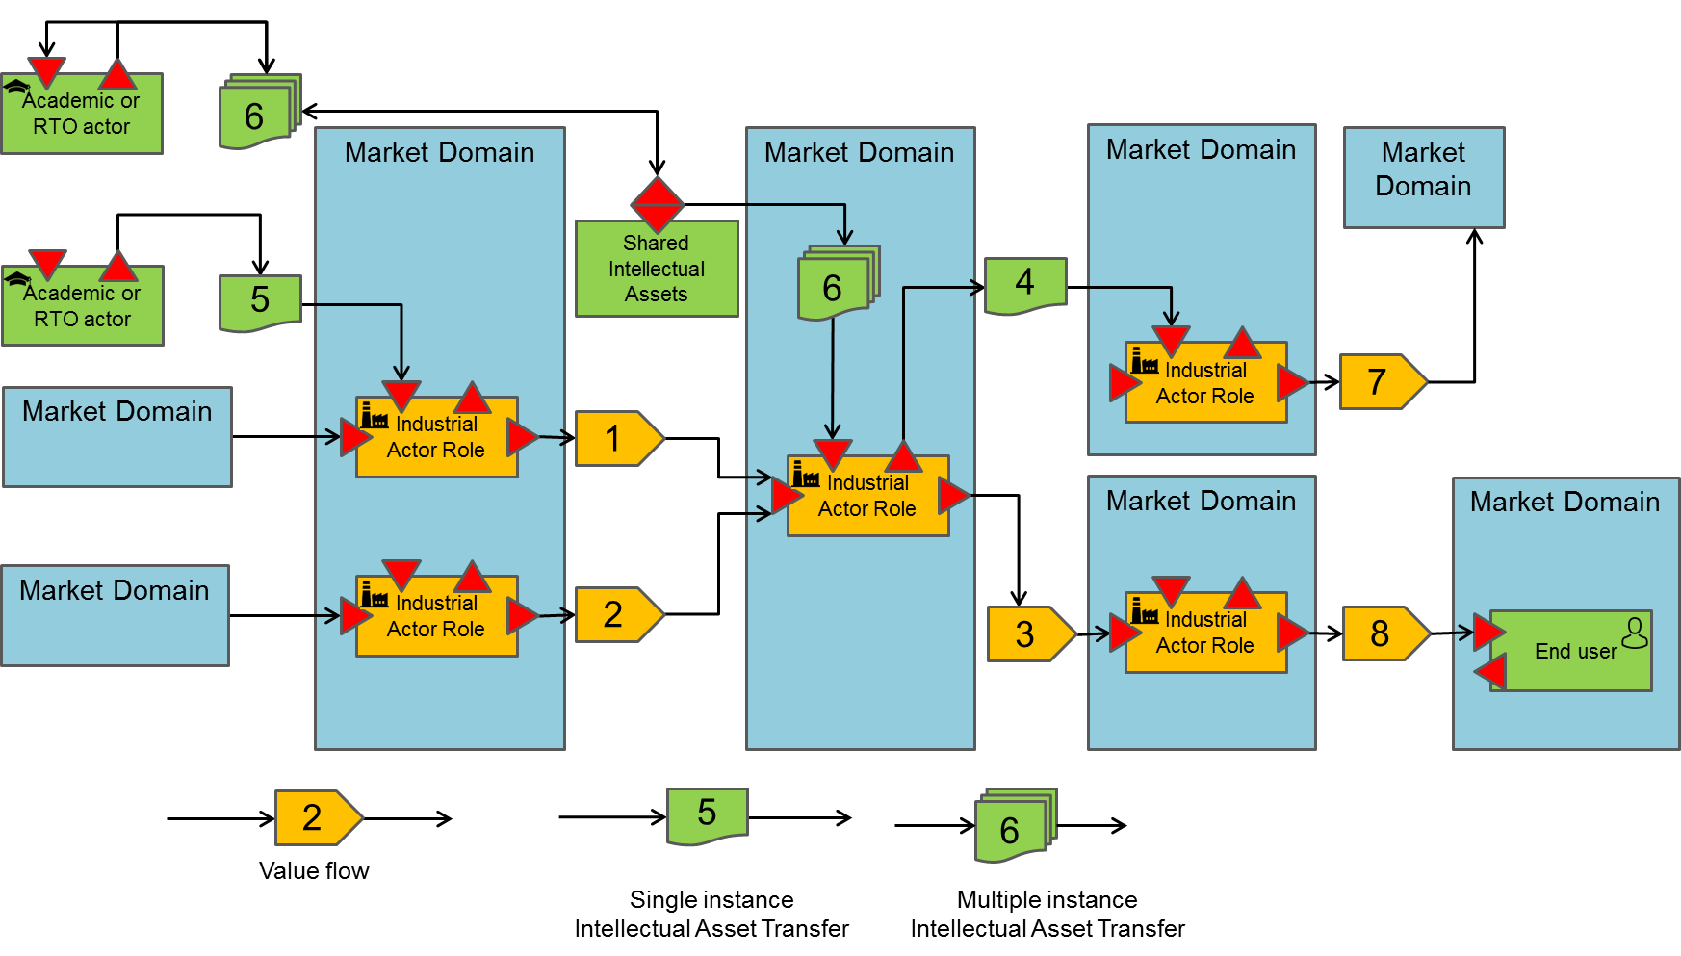

Figure 1 Value flow we must also represent a customer that may be different from the end users

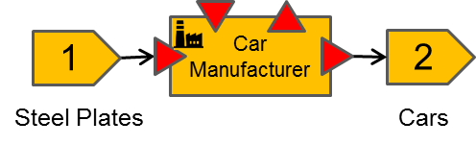A value flow diagram is represented as a directed graph (here from left to right) where economic actors collaborate together in order to produce some kind of good or service. It is key to representing the customers and end users that may provide invaluable information on market size and segmentation. Economic actors can be either business or academic actors that may contribute to the value chain through patent transfer or open source repository development necessary to deliver the expected goods or services. Academic actors are not the key actors of the value chain in the analysis of the potential of a business; but their role may be central to enable a business actor to become capable to deliver.

Economic actors consume input value flows and transform them into output value flows. A value flow is an exchange of goods or services between a producer and a consumer of that value. ‎**Error! Reference source not found.** shows an example of value flow transformation. In car manufacturing, plates of steel enter in the value creation process run by car manufacturers. Steel plates are transformed into cars which is the output value flow. Steel plates become part of car*s.*

Figure 2 Car manufacturer Value flow transformation

Figure 3 Robots as a leverage value flow in car manufacturing

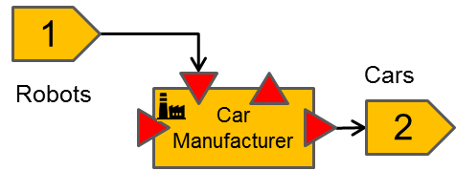

A second kind of value transfer exists: The leverage value flow. A leverage value flow is a value transfer towards an economic or an academic actor that has a leverage effect on the value transformation process of the receiver. It participates in the value transformation process without becoming part of it (here arrows on the incoming triangle of the Actor role). The leverage value flow may have two different impacts: Either it can improve the efficiency of the output value production process without changing the nature of the value flow so generating more incoming cash streams, or it can be an enabler of a value shift. By value shift we mean generating a new kind of value flow, different from the one that the economic actor has been able to produce so far. ‎Figure 3 shows that robots are a leverage value flow in the car manufacturing business. Robots do not become part of cars but add value in the cars whereby using robots in the manufacturing process we can expect higher quality cars , or cheaper cars. In other words, generating more value for money.

The notation elements are more systematically described in the following text:

*An industrial actor is an entity role that consumes one or more input value flows (left input arrow) and produces one or more output value flows or intellectual assets (right output arrow) in a specific market. By role, we mean that the industrial entity is reduced to its interaction in a specific market. E.g. Thales sells railway signalling systems and satellites, which are two different markets and thus correspond to two different business roles.*

*An industrial actor activity can benefit from additional contributions in the form of leveraged value flows or intellectual assets that have a leverage effect on its value creation process (vertical inbound arrow). This is called leveraged input. The value entering from that leveraged input entry is not integrated into the outgoing value stream; it helps make the transformation of input value flows into output value flows. For example: Academic knowledge, design environments / simulation tools helping to define products, manufacturing machines, and open-source code are all input values which improve the value created. It may also occur that an industrial actor also produces output leverage value flows, values which are not core elements of its business model.*

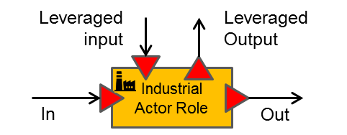

A value flow is a flow of products or services. Value flows are different from cash streams that may follow a different path than value flows. How cash streams are captured will be described in the next section.

*A value flow is an exchange of goods or services between a producer and a consumer of that value. Goods and services are produced in unbounded multiple instances. For example, cars leaving a production line, video-on-demand movies etc.*

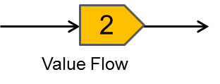

Industrial actors work in a given business domain or target their offer for a target business domain.

*A market domain is a container of actors (business or consumer actors) which compete or complement each other’s to deliver kinds of products and services. They are represented according to the left-hand side formalism.*

*We will focus on evaluating the size of the accessible market without trying to represent all the actors that make it up.*

*A market domain is also where the competition lives. If the R&D project intends to deliver an incremental or disruptive value proposition into a market domain, it is essential that the disruptive value proposition is articulated in the proposal.*

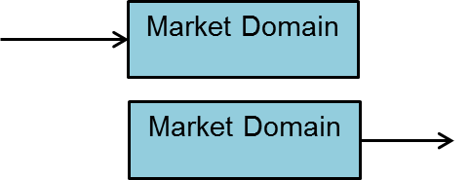

Academic actors’ fundamental goal is not to deliver products and services into a market; it is to deliver intellectual assets to economic actors that are more efficient at creating new kinds of values to markets (what we call innovation) or at improving existing value flows. An intellectual asset is discrete compared to a value flow: academic actors transfer intellectual assets non-recurrently or incrementally, while value flows are continuous (repetitive) exchanges. Representing academic actors in the value chain clarifies their catalytic role in the value chain: if the intellectual asset is not transferred, economic actors are not able to provide the value stream corresponding to the promises of the project.

*An academic actor is similar in every respect to an industrial actor except that it produces and consumes only leverage value. There is no value flow production in any dedicated business market that is ruled by competition. The leverage value takes the form of intellectual property or intellectual assets.*

*Of course, this is a reduced definition of academics and RTO. E.g. It is often the case that RTOs sell access to some prototyping infrastructure for industrial experimentation. This is a transitional situation necessary to enable a technology transfer at a later stage. Remember that we are interested in the targeted value chain definition; the transitional situation may occur during a project but should not last.*

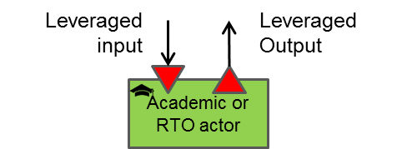

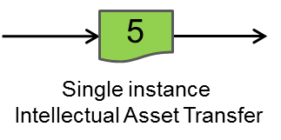

*A transfer of intellectual property corresponds to an non-recurrent transfer of intellectual asset likesome knowledge corresponding to patents, property rights etc.*

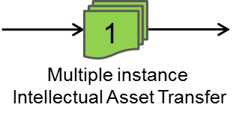

*This representation is adopted when several instances of the same intellectual asset are transferred like open-source code updates.*

End users are individuals, consuming products and services available in the public market.

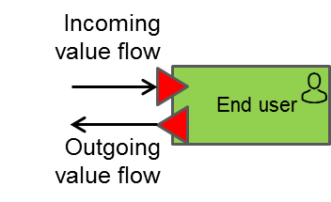

*An end user lives in the public sphere, is a consumer of value flows, can generate cash streams (typically when paying for goods or services) and may be also able to generate value flows. E.g. collecting data from end-user experience generates a value flow.*

By their very nature, economic actors at the start of the value chain (left-hand side of ‎Figure 1) produce the most generic technologies in the value flow while at the end (right side of the figure) we find vertical domain actors (automotive, energy, health ...) producing the least generic technologies and applications which are the closest to the social sphere.

Figure 1 also represents a type of role corresponding to the management and sharing of intellectual property assets (typically corresponding to the open source model). This type of entity does not produce value directly; contributors who exchange intellectual assets with this intellectual storage facility generate value through the use they make of shared technology.

*A shared intellectual assets repository receives and makes available an intellectual value to other actors, whether industrial or academic. This value may or may not be the materialisation of accumulated knowledge.*

*The extension of these accumulated intellectual assets is produced by increments of any actor using the existing content (outgoing arrow) and storing an extension or modification to the repository (incoming arrow).*

*An actor may, of course, simply be a consumer of an intellectual asset without contributing to its improvement.*

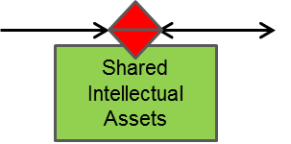

**Example:**

‎Figure 4 below represents an example of a (theoretical) value flow targeting the improvement of electricity production in the wind energy sector. It should be noted that the represented value flow is only a small part of the real value chain.

Academic1 maintains an OSS repository “OSS1”. The content of this repository, which is a Wind Turbine aerodynamic simulator, is used by the Wind Turbine Blade producer industrial actor as a leverage technology. Academic1 regularly updates the aerodynamic simulator, thus creating updates which are pushed to the Wind Blade Producer. In that example there is only one contributor to the shared asset but in general there may be several contributors to shared asset repositories.

Academic2 makes a one-off transfer of a wind field implantation simulator to a wind farm operator. Once the transfer is completed, Academic2 doesn’t own anymore the property of the Wind field simulator. There may be other patterns existing such as the granting of a licence for a limited period of time to its receiver for exclusive or non-exclusive use. One should represent all these situations the same way while the textual description of the value flow should clarify the details whenever possible.

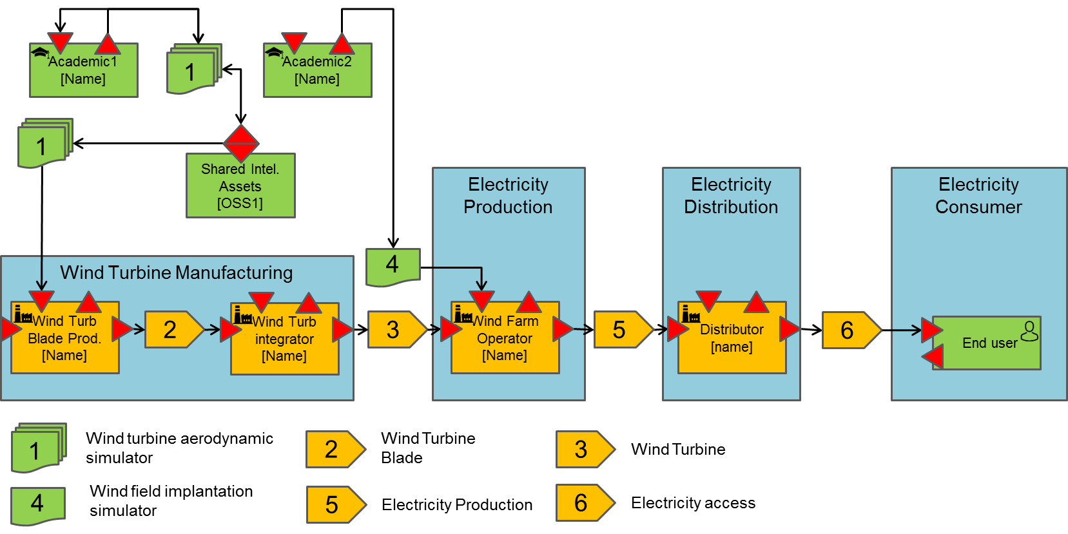Figure 4 Theoretical example of an electricity production value chain

The wind turbine blade producer produces a flow of wind turbine blades which is consumed by the wind turbine integrator. The wind turbine integrator produces a flow of wind turbines.

The wind turbine blade producer and wind turbine integrator operate within the wind turbine manufacturing market.

The wind turbine flow is consumed by the wind farm operator that installs and operates the wind farms. It produces electricity to the electricity distribution market. In order to deploy more efficient installations, it has acquired the property of the wind field implantation simulator. This simulator is a leveraged value transfer making its activity more productive.

The distributor actor operates in the electricity distribution market. The distributor transfers a flow of electricity access to the consumer market.

It is also interesting to stress that this value chain may accept other variants:

There are some cases where the distribution is not the customer of the electricity producer but the provider and in this case the end user is the customer of the electricity production when his first contact is the distributor.

We can also imagine having another actor between the distributor and the end-user which actually would be the final customer when the end users are not at all a customer (E.g. Think about the social departments of cities supporting electricity access for some of the population).

There is a possibility for a Value flow to have two actors being, at the same time, customer and supplier of each other at different stage of the production of a product. The next figure represents how this situation may be represented.

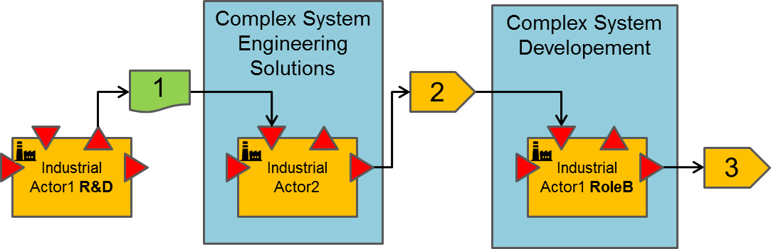

Figure 5 Multi-role business actor

In that figure we can see that the Industrial Actor1 intervene at two different stages of the value chain. There is nothing wrong with this as the value chain represents an industrial role within the value flow. Usually these roles correspond to different sub-organisations within a business actor. There may be several roles played by the same industrial actor which means that it can be involved in different markets, delivering different value flows. In the above figure, the R&D department transfers some intellectual property (e.g. a process, a technology prototype or a patent) to a second business actor that builds an offer from that input. That second offer is an industrial grade solution that can be procured by the business units of Actor 1. Since this was not the case with the intellectual property issued from the R&D department, there is a great business case for Actor1 as a whole to go that way. He has spent a limited effort (R&D) in the development of a solution and finally gets access to the industrial implementation of the solution at a reasonable price. Of course, this is possible as Actor2 is selling the industrial grade solution in a sufficiently large market that contains Actor1 Business Unit to make the deal viable.

Cash streams representation

As already stated, Cash stream representation describes how value chain actors will be rewarded for value delivery. This will help generators and receivers of the cash streams to work a pricing policy which is acceptable for the parties and answer the question: Are all value flow receivers willing to pay for the proposed value proposition?

Starting cash stream representation from a value flow is straightforward. Figure 6 shows the cash stream perspective derived from value flow described in ‎Figure 1. Basically, circulating the value flows in their opposite way reveals the cash streams.

However, there may be several variants for the above figure depending on participant’s strategies.

It is not mandatory for the industrial actor to fund academic or RTOs actor for the development and maintenance of shared intellectual assets. The development of shared intellectual assets may involve more sophisticated funding models so then they should be represented.

It is often the case that industrial actors or end-users are not willing to pay for the value which is delivered to them. However, value providers are still delivering their value to them in exchange for some other value. Think, for example, of the provision of the Google document suite delivered free of charge to individuals. Access to user data or user experience are two examples of the value that may be provided by end-users in exchange of the incoming value. In that case, the value generated from the end-user toward Google should be represented in the value flow diagram.

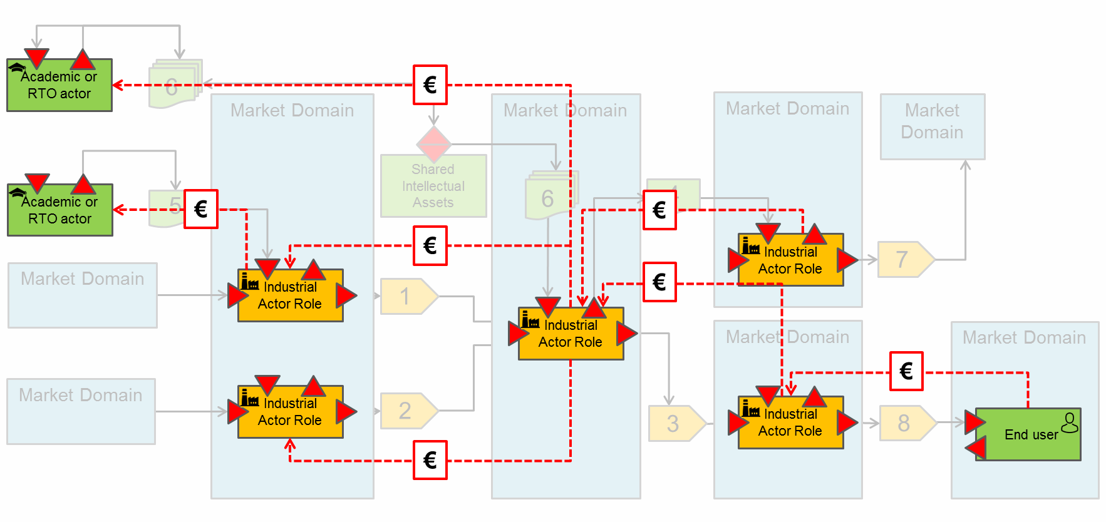

Figure 6 Some Cash stream perspectives

Representing the cash streams forces the business actors to ask themselves if there is a business case for their offer and often this can end up with the redesign of their business model, thus impacting in turn the value flow perspective and the products/services architectures. Then one should think about the cash stream perspective and the value flow perspective as two sides of the business between them, so one should iterate until both perspectives become balanced.

Notation elements:

*A cash stream is an exchange of currencies between a producer and a consumer. Exchange of currency can be recurring or not.*

*Non-recurring exchange of currency occurs, for example, for patent acquisition. Recurring exchange of currency may occur for reward of value flows. For example, annual subscription fees for a service. Composite currency flows may exist, for example, when there is an initial licence fee plus an annual renewal licence fee.*

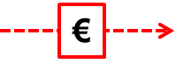

External environment

Delivering value to customers is not only a question of balance between a value proposition and pricing. There are other factors that may have a decisive impact on the capability of a new offer to generate new deals with potential customers in a market domain. These factors are external to the actors involved in the transaction but they may rule the business. These factors need to be identified as they may be powerful enough to kill or facilitate a business relationship between business actors. They are four types of external environment factors:

Influencers

Professional syndicates

Standardisation organisations

Regulation and certification authorities

The figure below suggests a representation for the factors that apply to a market domain.

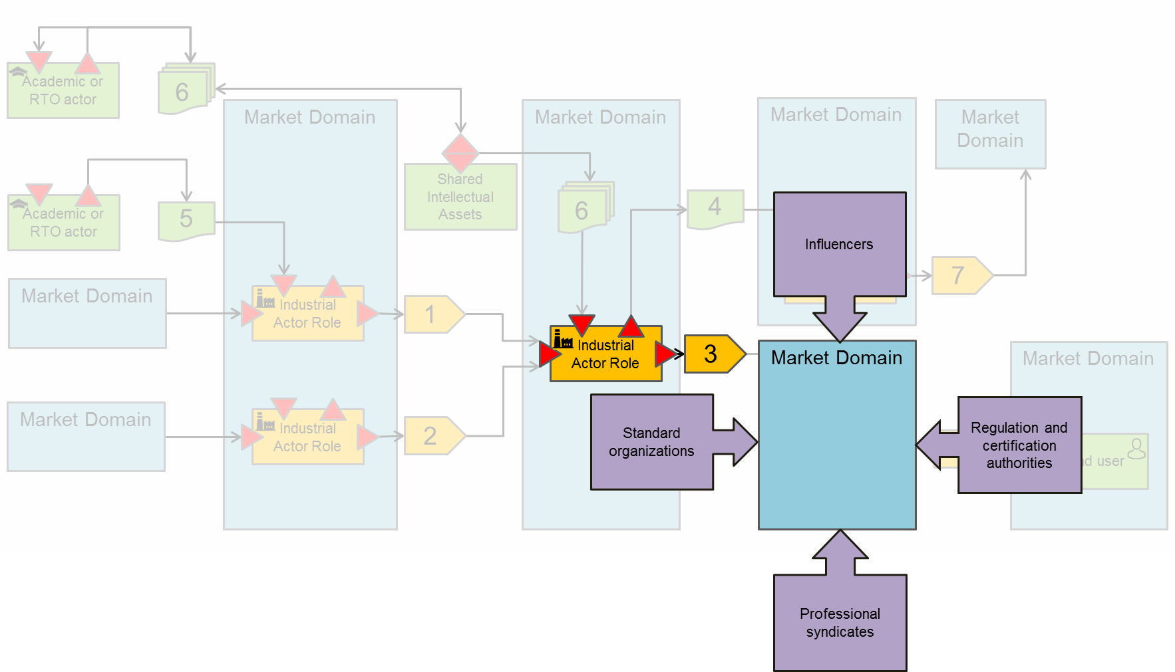

Figure 7 Environment constraints

Influencers are business actors such as large integrators that impose rules on their market domain, such as AIRBUS that defines the rules for procurement with which their subcontractors and sub-sub-contractors need to comply. It is important to be aware about these constraints before talking business with their sub-contractors.

Professional syndicates are professional organisations in direct touch with the professions; they strive to protect the interests of the members of their respective professional branch or branch of activity. They have the power to impose constraints on a specific business ecosystem in which the customer to which a value proposition is intended to be delivered is located.

Standardisation organisations are another kind of environment constraint or opportunity. The customer maybe part of it or even the supplier of a value proposition may be part of it. Standardisation organisations *define* standard but do not monitor their application. However, it is important to understand who is part of the standardisation organisations to understand where standards are heading, to understand if the value proposition discussed needs to comply with the standard and needs to remain compliant with it in the long term, and who can help in maintaining the standard in a way that is favourable for the value proposition supplier.

Regulation and certification authorities are slightly different from standardisation authorities. They are in charge of certifying that constraints and rules are fulfilled by products and services. Regulation and certification authorities behave as barriers for new actors entering existing market. One should not neglect the importance of those organisations to disabling new entrants to existing markets.

These four types of constraints that may apply to new business entrants are not independent of each other. Influencers often take a role in the definition of standards; they interact with certification authorities and professional syndicates. In a project’s proposal it is therefore necessary to identify all the actors, links and rules that may have an impact on the business. Once this is achieved, it is necessary to describe the partner strategy to overcome the potential issues or to use this environment as a business facilitator, for example by participating in the elaboration of standards. The exploitation and dissemination section of a proposal are good places to highlight the strategy for overcoming the potential issues.

There is no need to analyse the external environment for each actor of the value chain. There is a need to perform the exercise for the disruptive value flows of the project: only the value flows which exhibit a kind of value proposition that may be disruptive in a market domain. It is seldom that there are several outgoing disruptive value propositions from a research project. The project’s overall technology concept is usually the one needing attention.

Conclusion

In this document we have discussed how a value chain can help clarify a business vision analysing three different concerns. In ITEA proposals, these concerns should be addressed. They need to be discussed and agreed between participants. They need to be represented through diagrams but also described textually to explain the design decision that prevailed upon obtaining the design model. They need the involvement of a participant’s organisations beyond the R&D organisations to produce something beneficial to them. The value chain analysis is a good tool to transform research into innovation to make an impact on and in the market. The innovation can also be laid in the value chain organisation. Redesigning a value chain can be a good strategy to disrupt a situation where major leaders dominate the market. The value chain analysis usually has strong impact on the research itself due to the impact on architecture and performance level required.

End of the Annex C

1. Icons used in the value chain representation are available in the ITEA 3 Call 5 binder.